1. Canada-ASEAN Scholarships and Educational Exchange for Development

**DEADLINE**

The application period is open for the 2025 academic year. Canadian institutions must apply online on behalf of eligible candidates by **March 31, 2025, 11:59 p.m. EDT**. Only applications for Fall 2025 will be accepted under this competition.

**Requirements of the Scholarships :**

To be an eligible candidate for this scholarship, we must following this criteria.

* citizens of an ASEAN member state
* Brunei Darussalam, Cambodia, Indonesia, Laos (Lao People’s Democratic Republic (Lao PDR)), Malaysia, Myanmar, The Philippines, Singapore, Thailand, or Vietnam
* enrolled full-time at a post-secondary institution in an ASEAN member state
* paying tuition fees to that institution at the time of application and for the full duration of their exchange

Candidates are not eligible for this scholarship if they:

* hold or have a pending application for Canadian citizenship or permanent residency
* are already participating in a scholarship program funded by the Government of Canada
* are already enrolled in a degree, diploma or certificate program at a Canadian post-secondary institution
* have previously received a scholarship under the Canada-ASEAN Scholarships and Educational Exchanges for Development Program

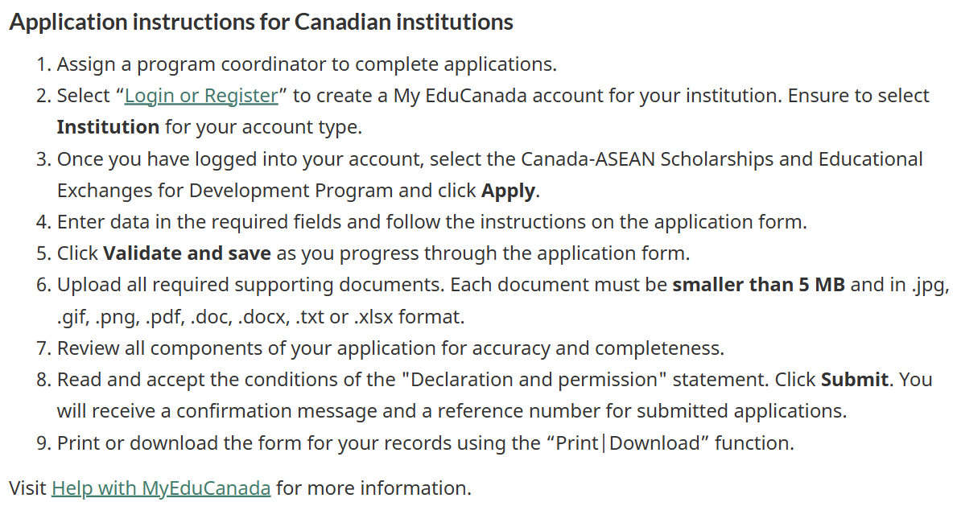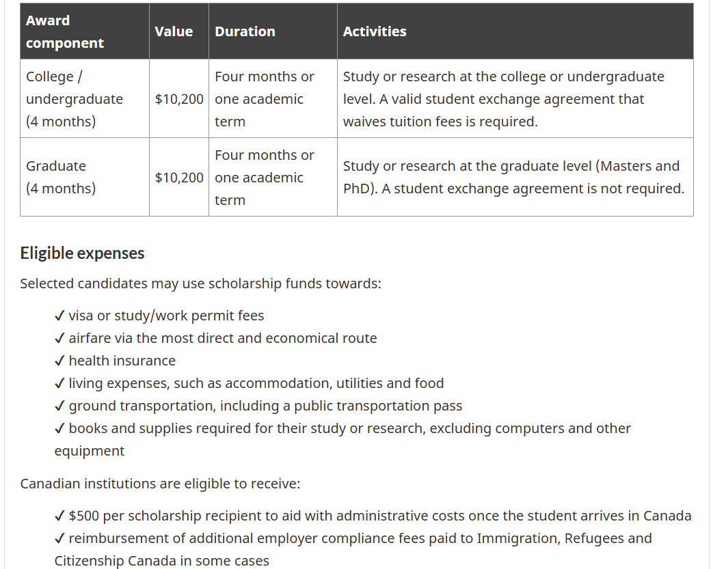

**Support Document**

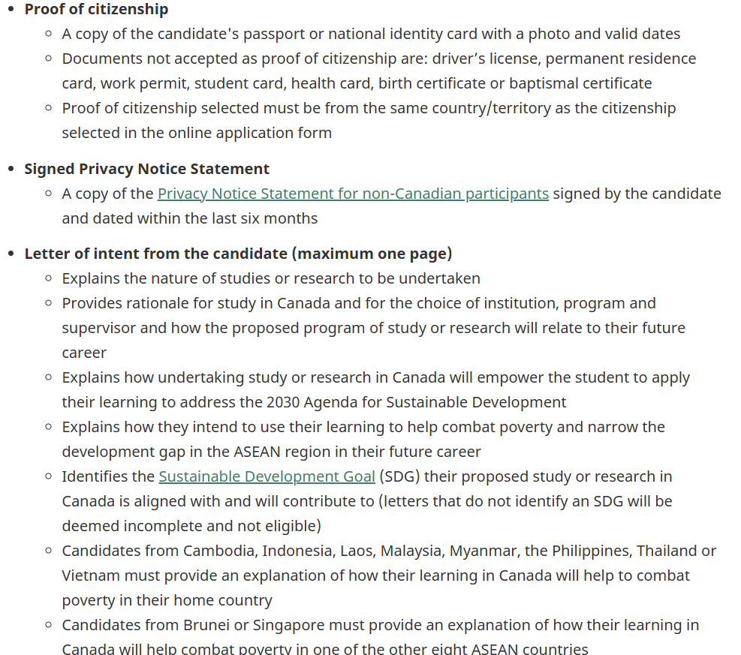

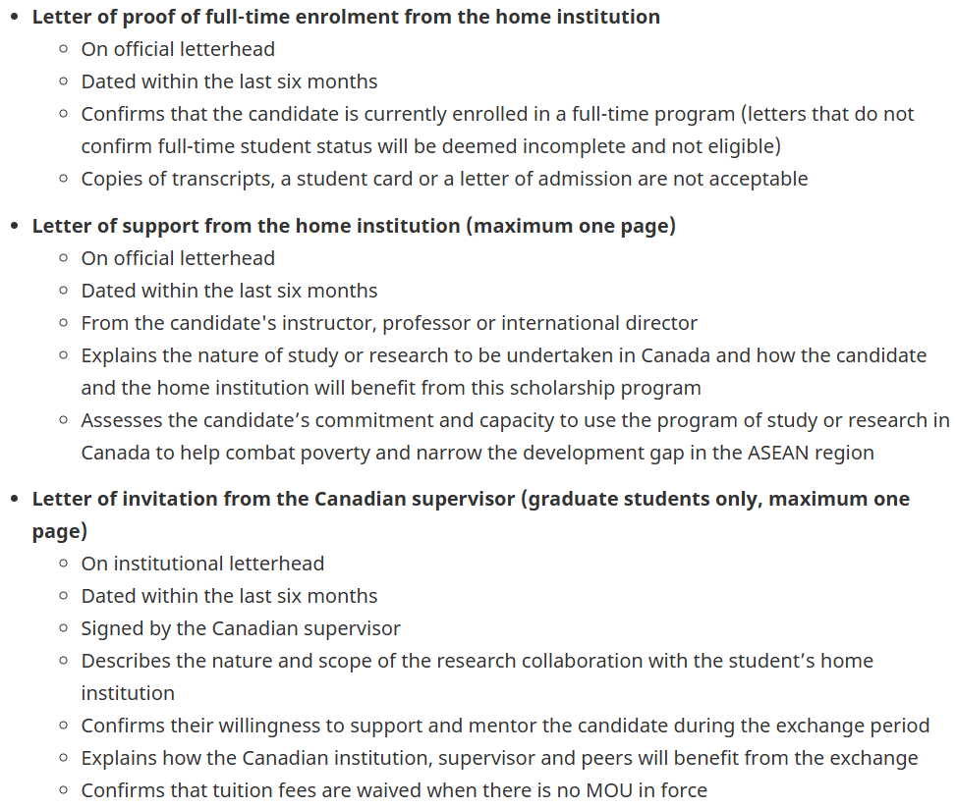

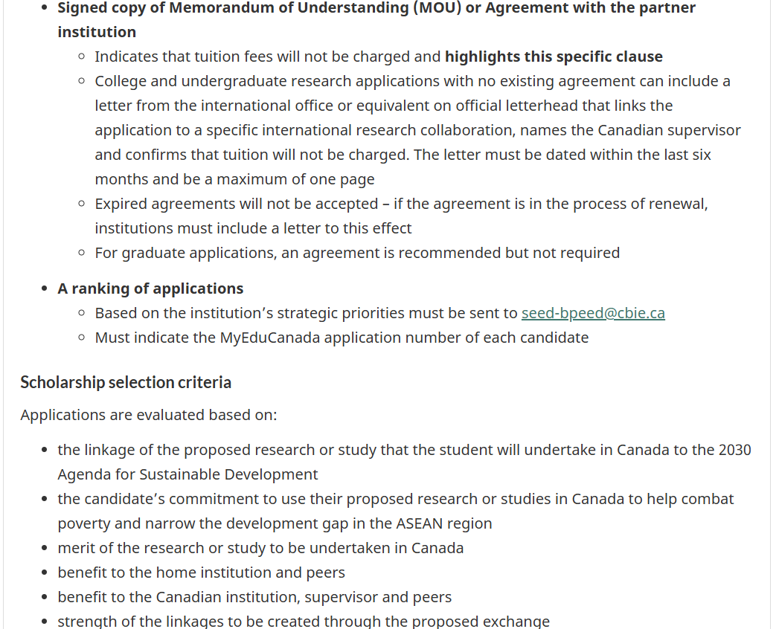

1. **YSEALI ACADEMIC FELLOWS PROGRAM**

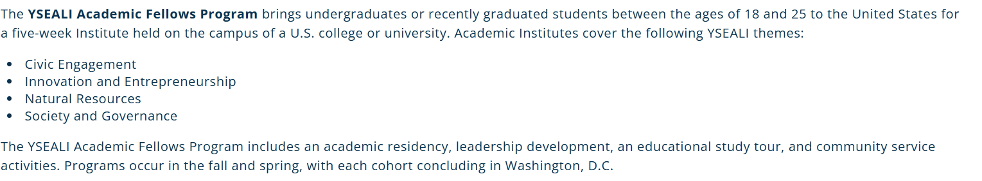

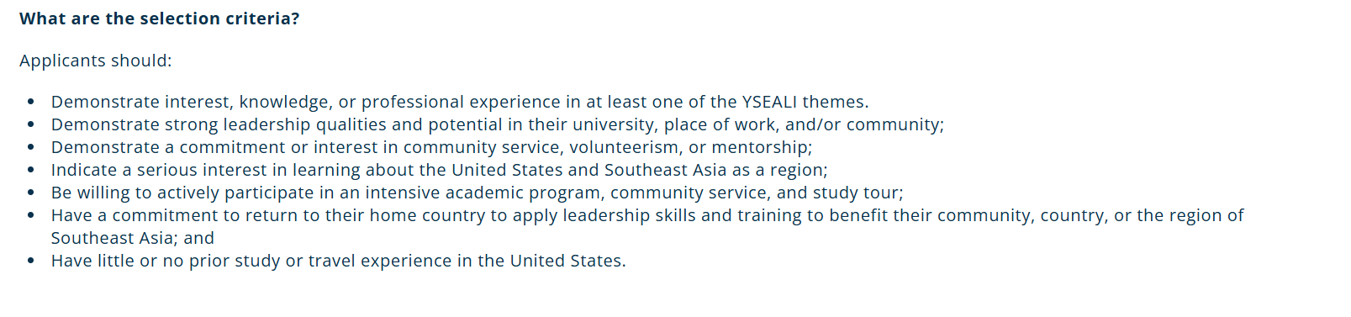 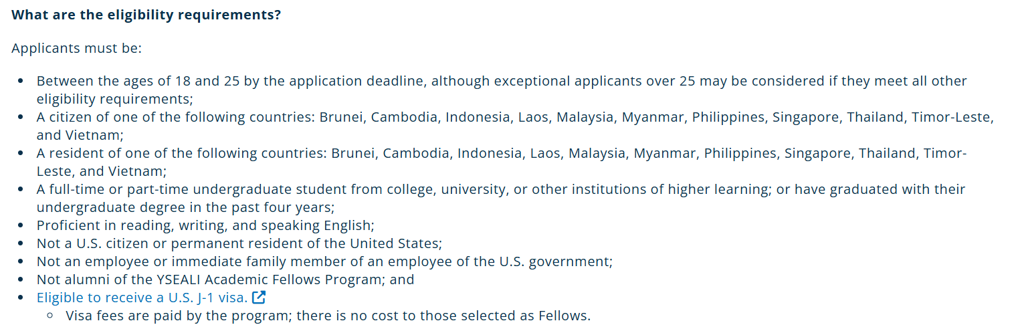

1. **AMGEN SCHOLARSHIP PROGRAM**



